Subject: Our Payroll System is Getting an Update
On July 9th, our payroll system from PayNorthwest will have an updated user interface. This means when you log in you will see some changes. These changes will make for easier navigation for the places you use most.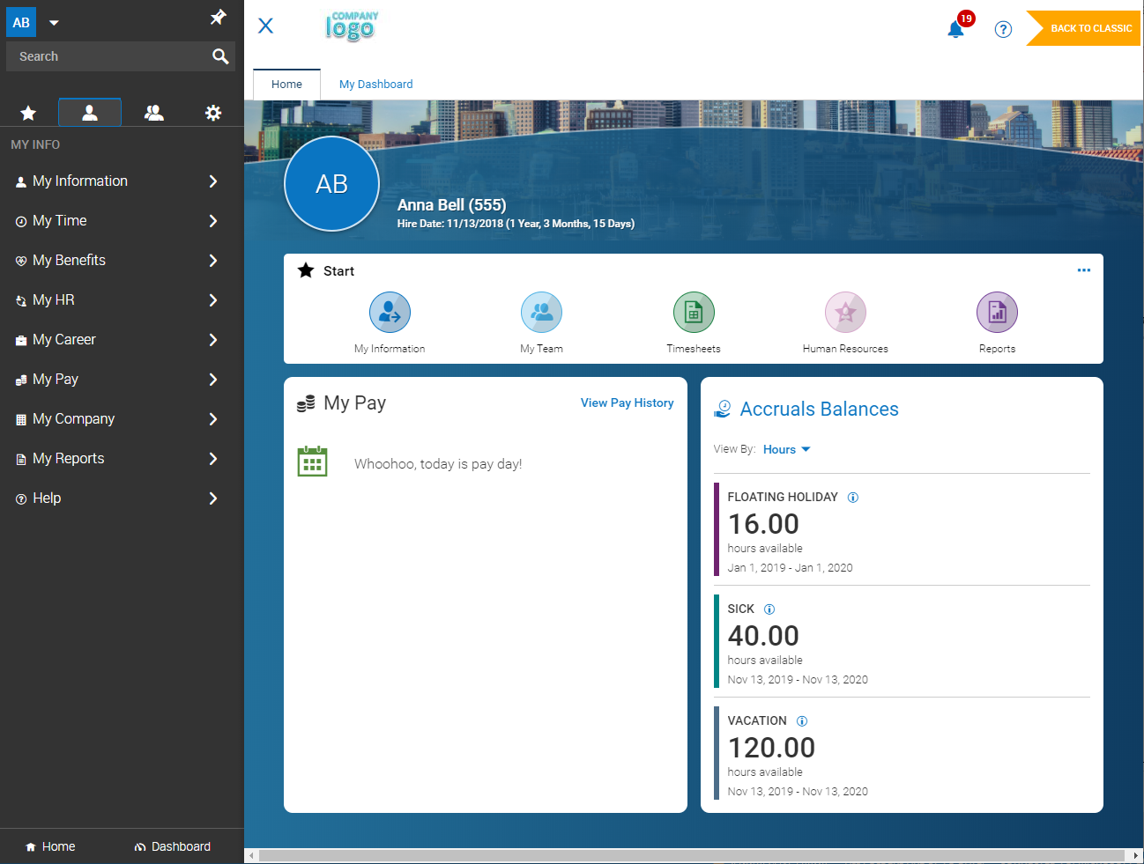To make the transition as easy as possible, you will see a toggle button in the upper right corner when you log in.
Use the toggle button to start familiarizing yourself with the new layout. You can also toggle back to the current view at any point.
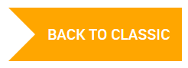
We also have a quick guide available showing the key navigation changes that you can reference.
Happy Toggling!

